**Title**: Mapping distributions of cod in the Gulf of Maine using Fisher Ecological Knowledge

**Authors**: Jonathan H. Grabowski, Neida Villanueva-Galarza, Wendi K. White, Katie Lankowicz, Vito Giacalone, Jackie Odell, Graham Sherwood

**Addresses**:

Department of Marine and Environmental Sciences, Coastal Sustainability Institute, Northeastern University, Nahant, MA 01908

Gulf of Maine Research Institute, Portland, ME 04101

Northeast Seafood Coalition

**Abstract**:

**Keywords**:

Atlantic cod (*Gadus morhua*), fisher ecological knowledge, fisheries management, stock assessment

**Introduction**

While scientists and fishers have differing approaches that shape their perspectives, they share the overarching goal of sustaining the stocks that they study, rely on for income, and/or use for sustenance. There is evidence that both science and resource management benefit from diverse perspectives (Aminpour et al. 2021), and there is a long history of collaborative fisheries research advancing from partnerships forming between scientists and fishers (Thompson et al. 2019). And yet, fishers’ perspectives, observations, and insights are often viewed as anecdotal or biased, and disregarded by scientists and managers (Pederson and Hall-Arber 1999, Ames 2003, DeCelles et al. 2017, Holzer et al. 2025). The failure to include their knowledge in fisheries science and management continues to occur despite ample evidence that their involvement can improve both processes and fisher buy-in to management decisions (Bergmann et al. 2004, Yates 2014, Stephenson et al. 2016).

Comanagement of fisheries and other common-pool resources has been offered as an alternative approach when open-access and traditional governance structures have not been effective at managing these resources, providing local community members with a greater voice in resource allocation (Ostrom 2009, Gutierrez et al. 2011, Cinner et al. 2012). For comanaged fisheries to work effectively, fishers should be meaningfully involved in the underlying science used in decision-making, such as designing, implementing, and interpreting the results of fisheries dependent and independent surveys used in stock assessments. Comanaged fisheries have been implemented successfully in a wide diversity of fisheries systems, from small-scale artisanal to industrial-scale fisheries globally (Folke et al. 2005, da Silva and Kitts 2006, Guidetti and Claudett 2019). Furthermore, fishers in comanaged fisheries often participate in designing management objectives and measures, such as in the Maine lobster fishery (Acheson 2013), where regional zone councils can implement local rules governing the fishery within their region. Ideally, this inclusive process results in enhanced management outcomes with greater buy-in from fishers (Ostrom 2009, Cinner et al. 2012).

Fisheries in federal waters in the U.S. are managed by regional Fishery Management Councils that include scientists, members of environmental non-government organizations (NGOs), and commercial and recreational fishers. The Magnuson-Stevens Reauthorization Act of 2006 required federal fisheries to transition to quota-based management, annual catch limits (ACLs), and accountability measures (AM), which rely heavily on our ability to accurately estimate fish abundances. However, if the abundance of a key stock is underestimated, fishers will rapidly reach their limit and struggle to avoid catching more, leading to unnecessary economic impacts on the fishery. Conversely, overestimated stock abundances could inadvertently promote overfishing, resulting in further declines in abundance. Thus, it is critical that the data sources used in the stock assessment process accurately reflect trends in stock abundances.

In the Northeastern U.S., the Northeast Fisheries Science Center’s Multispecies Bottom Trawl Survey is one of the key sources of fishery-independent data used in groundfish stock assessments. Other fisheries surveys, including the Massachusetts inshore survey, the Maine – New Hampshire inshore survey, and the Department of Fisheries and Oceans Canada bottom trawl survey on Georges Bank provide important measures such as relative abundance indices of juvenile fish that have yet to recruit into the fishery. While these surveys have been conducted over the past several decades, there is a widespread concern among fishers that many recent trends from the surveys do not agree with their collective observations from fishing over the past half century.

Stock assessments have indicated persistent declines in many groundfish stocks in the Gulf of Maine and Georges Bank region since at least the 1990s (NEFSC 2013, NEFSC 2022). This has resulted in a complex system of regulatory measures to reduce fishing mortality and protect spawning fish and essential habitats, including areas permanently closed to commercial fishing with bottom trawls (hereafter: closed areas). Though management efforts were designed to facilitate the recovery of groundfish stocks, some stocks are still considered to be overfished and experiencing overfishing (NEFSC 2022). The unusually slow recovery of these stocks despite commercial fishers’ adherence to regulations, compounded with the expected economic impact on commercial fishers given the expected continuance of reduced total allowable catch, culminated in a disaster declaration for the Northeast multispecies groundfish fishery in 2012. The disaster declaration has been in place for over a decade, which has led to a mass exodus from this fishery immersed in crisis. For instance, Murphy et al. (2018) reported a 55% decline in active vessels with allocated groundfish landings from 2007-2015, and this trend has continued since then.

Gulf of Maine Atlantic cod (*Gadus morhua*) is perhaps the most notable Northeast groundfish stock to have declined to and persist at levels of biomass beneath those able to deliver maximum sustainable yield (BMSY). Reduced allocations of key stocks like Gulf of Maine cod have had knock-on effects such as constraining fishers’ ability to harvest more abundant but spatiotemporally co-occurring stocks. Cod is therefore considered a “choke” species, as it prevents effective exploitation of other resources. This choke effect is a partial driver of reduced fishing effort, with overall fishing effort (# of groundfishing days) having decreased by 47% between 2007 and 2015. Furthermore, the reduced allocations deemed necessary to rebuild these stocks have directly impacted the industry economically, with revenues in the Northeast multispecies fishery having declined by 44% between 2007 and 2015 (Murphy et al. 2018) as a result of both decreases in landings and lower aggregate prices. The perceptions of recent groundfish population trends as per the commercial fishing industry in New England are at odds with what would be expected of stocks at extremely low levels of abundance. In particular, many fishers operating in the Gulf of Maine and on Georges Bank have reported challenges in actively avoiding species such as cod (dozens of members of the Northeast multispecies groundfish fleet, pers. comm.). The majority of members of the Northeast multispecies groundfish industry that were surveyed in 2018 indicated that incidental catches of choke species are impeding their ability to fish for other species (Scyphers et al. 2019). Furthermore, fishers stated that this problem has led to them having to lease additional quota, avoid fishing in certain areas, or stop fishing altogether. In addition to changing how and where they fish, these challenges have contributed to the chronic and high levels of stress, social disruption, and distrust in fisheries management currently experienced in the fishery (Scyphers et al. 2019). Efforts to quantify and incorporate fisher observations into management could benefit ongoing management of key stocks while also building greater buy-in into future management measures (Cinner et al. 2012, DeCelles et al. 2017).

To examine the distribution of cod in the Gulf of Maine, we interviewed 27 captains from the Northeast multispecies groundfish fishery. Specifically, we asked them to identify the distribution of cod in the following three management periods: 2004-2009 (when fishers were issued fishing days with a fixed amount of biomass for each species per day, hereafter ‘days-at-sea’), 2010-2012 (the inception of sectors and quotas, hereafter referred to as ‘onset of sectors’), and 2013-2022 (post-disaster declaration period marked by reduced allocations of cod, hereafter referred to as ‘sectors with cod cutbacks’). We also asked fishers to identify the species that they targeted during each management period. This approach allowed us to map the cod “footprint” or distribution in each period, as well as identify how fishers have modified both where they fish and what they primarily target in response to changing regulations and the ongoing disaster declaration due to reduced abundance estimates for cod and other key species.

**Methods**

To quantify the spatial distribution and extent of cod in the Gulf of Maine (GOM), we interviewed Northeast U.S. groundfish fishers and asked them to identify and draw areas on maps where they caught cod during three distinct management periods: 2004-2009 (days-at-sea); 2010-2012 (onset of sectors); and 2013-2022 (sectors with cod cutbacks). These three periods were chosen because they represent major changes in how the fishery was managed and consequently how fishers operated. Quotas for the GOM cod stock were cut dramatically from 2012-2015 and have remained low since, and consequently almost all fishers interviewed avoided cod during the ‘sectors with cod cutbacks’ period. Thus, we also asked fishers to identify areas where they avoided fishing during this period specifically due to the risk of catching more cod than their allocated quota.

We used a semi-structured interview approach to gather fisher ecological knowledge (FEK) of the current and past spatial extent of cod in the Gulf of Maine and Georges Bank (DeCelles et al. 2017). We interviewed current and recently retired captains from throughout New England. After our initial contacts were exhausted, we used a snowball approach wherein we asked interviewees to identify other fishers that they thought we should contact. Interviews were conducted at various libraries, coffee shops, homes, fishing vessels, and the Northeastern Seafood Coalition office. All fishers were interviewed separately except in the case where they worked on the same boat; in these instances, they were interviewed as a group. Interviews ranged from 30 minutes to 2.5 hours depending on individual availability and the information each fisher was willing to share. In total, 27 fishers were interviewed between November 2022 and March 2024.

To understand the extent of each fisher’s experience fishing in the GOM, interviews started with questions regarding their age and years of experience fishing, groundfishing, and targeting cod in the Gulf of Maine and Georges Bank. Next, we asked the same set of questions within each management period (see Table 1). We wanted to capture how much time each fisher spent targeting cod, and therefore how knowledgeable they would be about where to find cod during each period. These questions included how many days on average they spent groundfishing, what percentage of those days were spent targeting cod, and how much cod they caught per year on average during each period. After learning about their fishing practices, we asked interviewees to draw polygons for each period on either printed NOAA nautical charts or Google Earth Pro. The polygons denoted (1) where they actively fished for groundfish and (2) areas where they targeted and caught cod.

For each cod-specific polygon drawn, we asked the fished depth, time of year (specific month(s)), time of day (day/night), and abundance (low, medium, or high) of cod that were caught within it. For the final management period, fishers were also asked to draw polygons of areas that they no longer fished to avoid cod. If a fisher had accidentally caught cod in an area during this period and avoided it after, the polygon was documented as a cod-targeting area. For polygons designated as avoidance areas, we asked the depth, time of year (specific month(s)), and time of day (day/night) when they avoided an area based on their historical knowledge of cod. After completing the maps, we asked interviewees if they had observed any changes in the cod footprint and/or cod population abundances over the past 20 years.

The hand-drawn maps created from each interview were digitized in Google Earth Pro. Specifically, a cod footprint KML file was created by drawing in all polygons and including all descriptive information in the description box. Once all interviews were entered in Google Earth Pro, we read the KML file into R to visualize the cod footprint maps for the Gulf of Maine and Georges Bank for each of the three management periods. The description boxes for each polygon were used to select polygons and create footprint maps based on specifications around depth, time of day, time of year, and abundance or avoidance. Using this approach, we were able to identify cod ‘hotspots’, which we defined as areas denoted by two or more fishers independently as having abundant cod. Using this approach, we examined the spatial distribution and extent of the cod footprint as well as temporal dynamics in it across the three management periods.

**Results**

The 27 interviewees ranged in age from 39 to 80 years old, averaging 59.4 ± 9.0 standard deviation (SD) years old. While the majority of interviewees used an otter trawl to capture groundfish, we also interviewed fishers who target groundfish with gillnets, longlines, and jigging. Most interviewees had several decades of commercial fishing experience (avg.: 41.8 ± 10.2 SD years). Collectively, interviewees have accumulated over 1,100 years of fishing experience. Interviewees have spent 92.7% (38.7 ± 10.3 SD years) of their time fishing for groundfish while operating as commercial fishers, and 90.5% (37.9 ± 10.5 SD years) of that time targeting cod.

Examination of fishing behavior revealed some similarities across the three management periods. The number of days spent groundfishing did not vary greatly. Fishers spent an average of 150.0 ± 49.9 SD days fishing per year during the ‘days-at-sea’ period. This increased slightly to 158.3 ± 57.1 SD days during the ‘onset of sectors’ period and then decreased to 145.1 ± 71.6 SD days during the final management period. In contrast, the percentage of time that fishers spent targeting cod changed substantially across the three management periods. Fishers spent 41.9% ± 41.1 SD of their time targeting cod during the ‘days-at-sea’ period, then decreased to 28.1% ± 27.5 SD during the ‘onset of sectors’ period. Time spent targeting cod decreased dramatically to only 0.04% ± 0.2 SD during the ‘sectors with cod cutbacks’ management period.

On average, those interviewees who reported landings caught 52.7 metric tons (MT) ± 42.1 SD of cod during the ‘days-at-sea’ period, 40.7 MT ± 26.3 SD during the ‘onset of sectors’ period, and 4.3 ± 4.5 SD during the ‘sectors with cutbacks’ period. During the first two management periods, fishers targeted mostly similar species, with 4 of the 5 species occurring in both periods (cod, monkfish, pollock, and flatfish). During the ‘days-at-sea’ period, fishers commonly targeted haddock, but switched from haddock to hake during the ‘onset of sectors’ management period. The most striking change during the final management period was the absence of cod after being the most targeted species in the previous two management periods. In the final management period, fishers targeted haddock, pollock, flatfish, monkfish, lobster, hake, or left the groundfishing industry altogether.

The distribution of overall fishing effort for groundfish was relatively consistent across the three management periods (Figure 1). The greatest aggregation of fishing effort was in the western GOM to the west of the Western Gulf of Maine Closed Area (WGOMCA), with ~15-20 fishers fishing for groundfish in this region during each period. Fishing effort was also high in the center of the GOM in the area between the WGOMCA, Cashes Ledge Closure Area, and Closed Areas I and II, with ~10-15 fishers reporting fishing for groundfish in this central region. Fishing effort was low in the northeastern Gulf of Maine, to the west of Closed Area 1, and in between Closed Areas 1 and 2 along the southern extent of Georges Bank. These regions had <10 fishers report fishing for groundfish within them, and often <5 along the outer edges.

Next, we examined the spatial extent and distribution of the cod footprint by aggregating medium and high cod areas across all 12 months during each management period. During the ‘days-at-sea’ management period, we identified cod ‘hotspots’ (areas where two or more fishers reported catching cod) in the following three locations: (1) to the southwest and west of the WGOMCA, (2) between the northern edge of the WGOMCA and the Cashes Ledge Closure Area, and (3) along the northwestern edge of Closed Area 2 (Figure 2A). The cod footprint also included areas to the west and north of Closed Area 1 as well as along the Great South Channel and along the eastern edges of the WGOMCA. The cod footprint was largest during this management period, with the spatial extent of it amounting to 2,197,466 hectares. During the ‘onset of Sectors’ period, hotspots were still present to the southwest and west of the WGOMCA as well as along the northwestern edge of Closed Area 2 (Figure 2B). Furthermore, areas with cod were identified to the west of Closed Area 1, along the eastern edge of the WGOMCA, and in between the northern edge of the WGOMCA and the Cashes Ledge Closure Area. The spatial extent of the cod footprint during this period was reduced to 721,975 hectares.

During the final management period, there were very few areas where cod were caught given that most fishers were actively avoiding cod due to their cod quotas having been greatly reduced. The cod footprint included no hotspots, with only a few areas even reporting any catch, such as along the northwest edge of Closed Area 2, to the northeast and southwest of the WGOMCA (Figure 3A). The cod footprint of areas with reported cod catch was vastly reduced relative to the two earlier management periods, with the spatial extent covering only 343,707 hectares. However, the avoidance map (Figure 3B) by itself as well as when combined with the medium and high areas (Figure 3B) identified many of the same hotspots delineated in the earlier two management periods: 1) to the southwest and west of the WGOMCA, (2) between the northern edge of the WGOMCA and the Cashes Ledge Closure Area, (3) along the northwestern edge of Closed Area 2, and (4) along the Great South Channel. There were also areas identified to the west of Closed Area 1 and to the northeast of the Cashes Ledge Closure Area. Furthermore, the spatial extent of the combined map was much more similar to the earlier two management periods, covering 2,162,869 hectares of the Gulf of Maine and Georges Bank.

To examine monthly variability in the cod footprint, we aggregated medium and high polygons identified during each month separately during each management period. Due to limited overlap of polygons when separated by month, monthly maps identify areas where one or more fishers caught medium and/or high abundances of cod without delineating overlap among polygons. During the ‘days-at-sea’ period, cod areas were identified to the west and southwest of the WGOMCA as well as in between the northern edge of the WGOMCA and the Cashes Ledge Closure Area in all 12 months, though the size of these cod areas did vary seasonally (Figure 4). Meanwhile, the presence of cod areas on Georges Bank and the southern region of the Gulf of Maine varied substantially as a function of time of year. Specifically, cod areas in this region were largest early in the year, then shrank substantially during summer months, only to increase again towards the later months. During the ‘onset of sectors’ period, cod areas were once again identified throughout the year to the west and southwest of the WGOMCA, but more sporadically in between the northern edge of the WGOMCA and the Cashes Ledge Closure Area (Figure 5). Furthermore, cod areas were identified in spring as well as in late fall on Georges Bank, but less so in January, February, and during summer. Finally, very few cod areas were delineated during the final period (sectors with cutbacks) due to the large reduction in cod quotas that occurred at the onset of this period (Figure 6). Once again, a hotspot was identified in between the northern edge of the WGOMCA and the Cashes Ledge Closure Area, but it was smaller and detected more sporadically than during the previous two management periods. A hotspot was also detected along the northeastern edge of Closed Area I in February through May, and then was absent until fall, when it appeared in October and persisted through December. Once again, these hotspots were substantially smaller than those detected during the earlier two periods. Unlike the other two periods, no hotspots were detected in the western Gulf of Maine to the west of the WGOMCA, likely because this area was avoided due to high cod catches prior to the onset of cutbacks.

**Discussion**

The groundfish fishers interviewed in this study, through where they have landed and most recently have also avoided cod, collectively have created several “cod footprint” maps. Their knowledge of cod in the Gulf of Maine and Georges Bank comes from over 1100 years of fishing in aggregate, and they represent a substantial number of the fishermen in the fishery that are still actively fishing for groundfish. While fishing behavior has changed dramatically with changing regulations, cod hotspots derived from FEK were largely consistent over the last two decades when including areas intentionally avoided because of historically high cod abundance. Fisher ecological knowledge offers insight into the ecology of valuable species, and it can help build a more complete understanding of the distribution and abundance of fished species.

There was strong overlap in the areas identified by fishers as having moderate to high cod abundances during the earlier two periods despite a major transition in how the cod fishery is managed occurring in 2009. This is likely a result of fishers continuing to target cod largely in the same locations that they previously had because they still had the ability to land cod. Meanwhile, there was only partial overlap during these earlier periods between those identified by fishermen vs. hotspots documented from fisheries independent research such as the NEFSC trawl survey (Guan et al. 2017). Similar to our study, the NEFSC trawl survey documented high abundances of cod in the Western Gulf of Maine between 2004 and 2013, and to a lesser extent, along the eastern edge of Georges Bank (Guan et al. 2017) where fishers in this study also identified high cod abundance. Fishers identified a cod hotspot in the northern Gulf of Maine between the northern portion of the Western Gulf of Maine Closure Area and the Cashes Ledge Closure Area, whereas the trawl survey rarely captured cod in this region.

Disagreement between the NEFSC trawl survey and our cod hotspot map could result from differences in when or how much sampling occurred. Specifically, the NEFSC trawl survey runs in the spring (April to June) and fall (October to November), whereas the fishers interviewed in this study fish throughout the year, averaging ~150 days per year on the water. The NEFSC trawl survey covers the Gulf of Maine, Georges Bank, and southern New England with 60 tows each in the spring and fall, whereas each fisher typically samples a much smaller area more intensively, potentially helping identify hotspots when examined in aggregate. Another difference could stem from how they fished during these periods. Commercial fishers used trawls and gillnets designed to sample in a wider array of bottom habitat types than the NEFSC trawl survey is capable of sampling. The NEFSC initiated a longline survey in 2014, allowing for sampling across a greater variety of habitat types including more complex bottom. While this survey will be valuable for future comparisons, it unfortunately does not overlap with our earlier two periods. In general, cod hotspots identified by fishers that have not been well documented could help reshape our understanding of cod distribution.

The onset of the final period began with the fishery being declared a disaster in late 2012, resulting in dramatic cuts in Gulf of Maine quotas in 2013. The fishermen interviewed in this study went from targeting cod for 30-40% of total time spent fishing during the first two periods to 0.04% of their time targeting cod in the final period. The decline in cod landings among participants of the study matched that of the overall fishery, which declined by XX% (ref). Many fishers actively avoided cod during this final period, with one stating that “I have to be careful though. If we catch them (cod), I have to be on the phone with the sector manager to make sure that they’re available to buy. We’ll have to buy them and lose money just because we caught them. And it costs more to buy them than we can sell them for. So, I don’t want to do that either.”

The disaster not only had critical economic impacts but also led to chronic and severe levels of distress and social disruption experienced throughout the majority of the fishery over the past decade (Scyphers et al. 2019). That study also documented a consistent reduction in the number of boats still actively fishing, as have others (Murphy et al. 2018), with the fishery continuing to downsize since then as fishers age out of the fishery or chose to leave it as a consequence of experiencing continued socioeconomic hardship. In particular, the high levels of social impacts and mass exodus likely stem in part from the challenges of reduced cod quotas resulting in fishers having to avoid much of the area that they had historically fished in the Gulf of Maine. Captains were only able to land cod in the rare instances where they were fortunate enough to hold on to their limited cod quota until the end of the season and use it up quickly, explaining why the footprint expanded in March to May during this final period. While the fishing industry adapted by having to change where they fish and what they target, there was a high degree of overlap between the cod hotspots during the earlier periods and the combined map during the final period. Although most of the combined map is avoidance areas, it does largely align with fisheries independent data (Guan et al. 2017). Many of the fishermen also commented on observing aggregations of fish on their sonar in these areas that they believe are schools of cod. Future efforts to validate these hotspots would help advance our understanding on the distribution and abundance of cod in the Gulf of Maine.

There is longstanding debate over whether fisher ecological knowledge should be viewed as valuable scientific data and incorporated into decision making or biased and anecdotal (Pederson and Hall-Arber 1999, Ames 2003, DeCelles et al. 2017, Holzer et al. 2025). Holzer et al. (2025) argues that fishers have strong incentives to lobby for weaker regulations so that they can increase their landings in the short term even if it eventually results in fishery collapse. However, there are many examples where fisher ecological knowledge has been used successfully in fisheries management (Bergmann et al. 2004, Yates 2014, Stephenson et al. 2016), and that fisher buy-in and active participation in fisheries management (i.e., comanagement) often leads to positive outcomes for fisheries sustainability (Cinner et al. 2012).

A review of the source of scientific uncertainty in the northeast groundfish fishery over the past two decades revealed that annual harvest rates were 151% above the target while catches have consistently been below target catch (Wiedenmann and Jensen 2018). While multiple sources of scientific uncertainty were responsible for this discrepancy, they concluded that the largest driver of it was overestimated abundance, speaking to the need for additional data sources to be included in the process. Moreover, fishers consistently landing within their limits and then being told that overharvesting has still occurred has likely eroded their trust in fisheries management, which is very low in this fishery (Scyphers et al. 2019). Efforts to quantify the groundfish fishery’s knowledge could enhance fisheries management by increasing the sources of data available on key species and help rebuild trust.

This study represents several centuries of collective fishing experience; however, the following limitations deserve consideration. First, we were only able to interview 27 fishermen, with higher spatial coverage in some areas such as the western portions of the Gulf of Maine, while others were sparser (i.e., Georges Bank and the eastern section of the Gulf of Maine). Additional interviews in these underrepresented areas would enhance our ability to use fisher ecological knowledge to quantify and delineate the cod footprint throughout its range. Previous efforts to extract fisher ecological knowledge from the Northeast groundfish fishery regarding cod spawning areas (DeCelles et al. 2017) and cod stock structure (Ames 2004) were able to interview 30-40 fishermen. Both were conducted 1 to 2 decades ago, prior to the extensive contraction of the fishery that has occurred since then. Our efforts represent a solid proportion of the remaining active fishers and are an attempt to capture this valuable information while still available. Future efforts to quantify the distribution and abundance of groundfish species in the northeastern U.S. will be challenged by the paucity of fishers still actively fishing in this region. However, similar challenges exist for the NEFSC trawl survey, with ageing survey vessels, offshore wind lease sites, gear conflict, and other challenges limiting the ability of the survey to comprehensively sample the region. Another limitation of the study is the inability of fishers to land cod during the final period due to reduced quotas. A targeted collaborative survey bringing together fishers and scientists could be designed to sample and validate the avoidance portion of the footprint, which in turn would potentially help rebuild trust in fisheries science and management in the region.

We interviewed groundfish fishermen about the current and past distribution of cod in the Gulf of Maine and used their collective knowledge to develop cod footprints or heat maps in the region. Their collective knowledge is built from spending several months at sea often targeting cod in the earlier two periods and then avoiding them in the more recent period. Cod stock assessments have been fraught with retrospective patterns over the past couple of decades resulting from disagreements between harvesting and catch rates (Wiedenmann and Jensen 2018). This reoccurring problem suggests that additional sources of data on the distribution of cod in the Gulf of Maine would benefit fisheries management. Furthermore, the cod footprint offers an opportunity to groundtruth whether fisheries independent data sources such as the NEFSC trawl survey with low sample volume are adequately sampling cod. In addition, it could help inform efforts to establish a targeted survey aimed at quantifying the abundance of cod in the Gulf of Maine. Fisher ecological knowledge about the distribution and abundance of key species should be incorporated into fisheries science and management more regularly. Adding it as a term of reference in fisheries stock assessments would elevate its importance while also potentially giving fishing communities greater agency in fisheries management.

**Acknowledgements**

**Literature cited**

Ames, T. Aug 1, 2003. "Putting Fishermen's Knowledge to Work: The Promise and Pitfalls.".

Ames, E. P. 2004. Atlantic cod stock structure in the Gulf of Maine. Fisheries 29:10-28.

Aminpour, Payam, Steven A. Gray, Alison Singer, Steven B. Scyphers, Antonie J. Jetter, Rebecca Jordan, Robert Murphy, and Jonathan H. Grabowski. 2021. "The Diversity Bonus in Pooling Local Knowledge about Complex Problems." Proceedings of the National Academy of Sciences - PNAS 118 (5): 1–7. doi:10.1073/pnas.2016887118. <https://www.jstor.org/stable/27006141>.

Bergmann, M., H. Hinz, R. E. Blyth, M. J. Kaiser, S. I. Rogers, and M. Armstrong. 2004. "Using Knowledge from Fishers and Fisheries Scientists to Identify Possible Groundfish ‘Essential Fish Habitats’." Fisheries Research 66 (2): 373–379. doi:10.1016/j.fishres.2003.07.007. <https://dx.doi.org/10.1016/j.fishres.2003.07.007>.

Cinner, Joshua E., Tim R. McClanahan, M. Aaron MacNeil, Nicholas A. J. Graham, Tim M. Daw, Ahmad Mukminin, David A. Feary, et al. 2012. "Comanagement of Coral Reef Social-Ecological Systems." Proceedings of the National Academy of Sciences - PNAS 109 (14): 5219–5222. doi:10.1073/pnas.1121215109. <https://www.jstor.org/stable/41588135>.

da Silva, P. P., and A. Kitts. 2006. Collaborative fisheries management in the Northeast US: Emerging initiatives and future directions. Marine Policy 30:832-841.

DeCelles, Gregory R., David Martins, Douglas R. Zemeckis, and Steven X. Cadrin. 2017. "Using Fishermen’s Ecological Knowledge to Map Atlantic Cod Spawning Grounds on Georges Bank." ICES Journal of Marine Science 74 (6): 1587–1601. doi:10.1093/icesjms/fsx031.

Folke, C., T. Hahn, P. Olsson, and J. Norberg. 2005. Adaptive governance of social-ecological systems. Annual Review of Environment and Resources 30:441-473.

Guidetti, P., and J. Claudet. 2010. Comanagement Practices Enhance Fisheries in Marine Protected Areas. Conservation Biology 24:312-318.Acheson, J. M. 2013. Co-management in the Maine Lobster Industry: A Study in Factional Politics. Conservation and Society 11:60-71.

Gutiérrez, Nicolás L., Ray Hilborn, and Omar Defeo. 2011. "Leadership, Social Capital and Incentives Promote Successful Fisheries." Nature (London) 470 (7334): 386–389. doi:10.1038/nature09689. <https://link.springer.com/article/10.1038/nature09689>.

Murphy, Tammy, Gregory Ardini, Maria Vasta, Andrew Kitts, Chad Demarest, Jon Walden, and Daniel Caless. 2018. 2015 Final Report on the Performance of the Northeast Multispecies (Groundfish) Fishery (May 2007 – April 2016).

NEFSC (Northeast Fisheries Science Center). 2013. 55th Northeast Regional Stock Assessment Workshop (55th SAW) Assessment Report. NEFSC Ref Doc. 13-11.

NEFSC (Northeast Fisheries Science Center). 2022. Stock Assessment Update of 14 Northeast Groundfish Stocks Through 2018. NEFSC Ref. Doc. 22-06.

Ostrom, E. 2009. A General Framework for Analyzing Sustainability of Social-Ecological Systems. Science 325:419-422.

Pederson, J. and M. Hall-Arber. 1999. "Fish Habitat: A Focus on New England Fishermen's Perspectives." American Fisheries Society Symposium (22): 188–211. <https://search.proquest.com/docview/17428620>.

Scyphers, Steven B., J. Steven Picou, and Jonathan H. Grabowski. 2019. "Chronic Social Disruption Following a Systemic Fishery Failure." Proceedings of the National Academy of Sciences - PNAS 116 (46): 22912–22914. doi:10.1073/pnas.1913914116. <https://www.jstor.org/stable/26861371>.

Stephenson, Robert L., Stacey Paul, Martin A. Pastoors, Marloes Kraan, Petter Holm, Melanie Wiber, Steven Mackinson, Dorothy J. Dankel, Kate Brooks, and Ashleen Benson. 2016. "Integrating Fishers’ Knowledge Research in Science and Management." ICES Journal of Marine Science 73 (6): 1459–1465. doi:10.1093/icesjms/fsw025. <https://search.proquest.com/docview/1808622361>.

Thompson, Susan A., Robert L. Stephenson, George A. Rose, and Stacey D. Paul. 2019. "Collaborative Fisheries Research: The Canadian Fisheries Research Network Experience." Canadian Journal of Fisheries and Aquatic Sciences 76 (5): 671–681. doi:10.1139/cjfas-2018-0450. <https://www.proquest.com/docview/2213065527>.

Yates, K. L. 2014. "View from the Wheelhouse: Perceptions on Marine Management from the Fishing Community and Suggestions for Improvement." Marine Policy 48: 39–50. doi:10.1016/j.marpol.2014.03.002. <https://dx.doi.org/10.1016/j.marpol.2014.03.002>.

**Tables**

**Table 1. Questions we asked fishermen during interviews**

|  |
| --- |
| Part 1: Demographic questions   1. What is your year of birth? 2. How many total years of experience do you have commercial/recreational fishing? 3. How many years of experience do you have commercial/recreational fishing for groundfish in the Gulf of Maine/Georges Bank? 4. How many years of experience do you have fishing specifically for cod in the Gulf of Maine/Georges Bank?   Part 2-4: Cod fishing activity (all questions asked for each time period)   1. On the chart/s provided could you outline the full range of your groundfishing activity between (*insert time period*). What gear type did you use during this time period? 2. How many days per year did you spend fishing for groundfish during this earlier time period? 3. Out of the days you spent per year groundfishing how many or what percentage of those days were spent targeting cod? 4. How much cod did you catch per year? 5. What size were the majority of cod that you encountered? 6. On the chart/s provided, please draw lines around the areas where you targeted and captured cod (take your time and draw irregular shapes that best delineate the depth contours and bottom substrates if they are important to the likelihood of successfully finding good cod fishing) during this earlier time period.    1. Please try to provide any seasonal periods that apply to the cod fishing in each area you’ve outlined. Also, please note if any Day / Night affects apply to an area.    2. What depths were you fishing at?    3. How would you describe the habitat of this area?    4. Please score each polygon as either an area where a high (H), medium (M) or low (L) catch rate of cod was expected when fishing there. Define what you mean by this amount, how many cod you would catch on average when fishing there. 7. If you didn’t mark an area that you targeted cod, is there an area you would like to outline that you specifically avoided because of your historical cod knowledge?   Part 5: Secondary questions that could be asked if time permits   1. Do you feel that the spatial footprint of cod has changed? If yes, how? 2. Do you feel that cod size, depth, habitat, or other characteristics have changed? If yes, how? 3. What were your target species for each time period? 4. What is a good address to send a small thank you to? 5. Can you suggest anyone else that might be willing to talk to us? |

**Table 2. Fishermen demographics and catch data. Numbers in parentheses are the sample size for each category.**

|  |  |  |  |
| --- | --- | --- | --- |
|  | **Days-at-Sea**  **(2004-2009)** | **Onset of Sectors**  **(2010-2012)** | **Sectors with Cod Cutbacks (2013-2022)** |
| **Days per year spent groundfishing** | 150 (*n* = 26) | 158 (*n* = 25) | 145 (*n* = 21) |
| **Percentage of time spent targeting cod** | 41.9 (*n* = 21) | 28.14 (*n* = 22) | 0.04 (*n* = 23) |
| **Average cod caught per year (metric tons)** | 52.70 (*n* = 14) | 38.82 (*n* = 14) | 4.67 (*n* = 13) |
| **NOAA cod landings for New England (metric tons)** | 1485.0 | 1380.0 | 244.0 |

**Quick reference sample size table**

|  |  |  |  |
| --- | --- | --- | --- |
|  | **Days-at-Sea**  **(2004-2009)** | **Onset of Sectors**  **(2010-2012)** | **Sectors with Cod Cutbacks (2013-2022)** |
| **Days per year spent groundfishing** | 26 | 25 | 21 |
| **Percentage of days spent targeting cod** | 21 | 22 | 23 |
| **Average cod caught per year (metric tons)** | 14 | 14 | 13 |
| **Gear type** | 27 | 27 | 25 |
| **Species targeted** | 26 | 26 | 23 |
| **Age** | 25 |  |  |
| **Years fishing** | 27 |  |  |
| **Years groundfishing** | 27 |  |  |
| **Years fished for cod** | 27 |  |  |

|  |  |  |  |  |
| --- | --- | --- | --- | --- |
|  | **2004** | **2010** | **2013** | **2013 avoid** |
| **hectares** | 2,197,466 | 721,975 | 343,706.9 | 2,162,869 |

**Figure Legend**

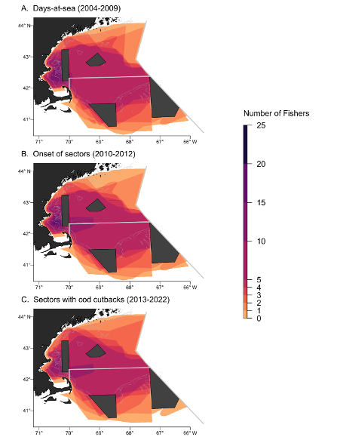

Figure 1. Fishers were asked to outline their groundfishing region at large to represent where they have experience fishing for groundfish during each management period. [A] Groundfishing region for the days-at-sea period (2004-2009), n=27. [B] Groundfishing region for the onset of sectors period (2010-2012), n=27. [C] Groundfishing region for the sectors with cod cutbacks period (2013-2022), n=24. Scale bar represents how many fishers have knowledge of any given area.

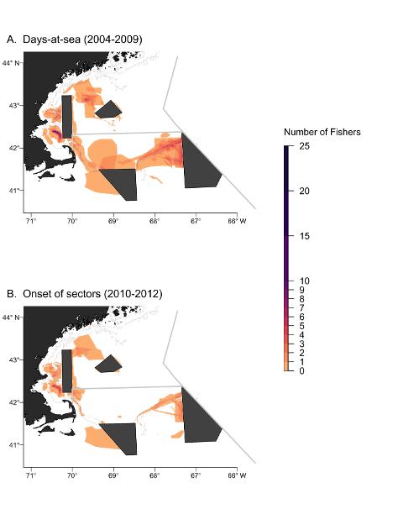

Figure 2. Polygons representing areas of medium or high cod abundance for [A] the days-at-sea management period (2004-2009) and [B] the onset of sectors management period (2010-2012). Scale bar represents how many fishers had overlapping medium to high cod abundances for any given area, (n=27).

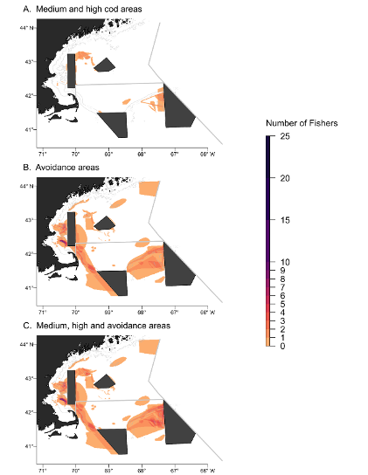

Figure 3. Fishers reported changes in fishing practices after the cod cutbacks in 2013. For the last management period (2013-2022) fishers were asked to designate polygons where they [A] were able to catch medium-high abundances of cod and [B] avoided fishing due to concern of catching more cod than their quota allowed. [C] A combination of polygons where fishers caught and avoided cod for the last period. Scale bar represents how many fishers had overlapping knowledge for any given area, (n=24).

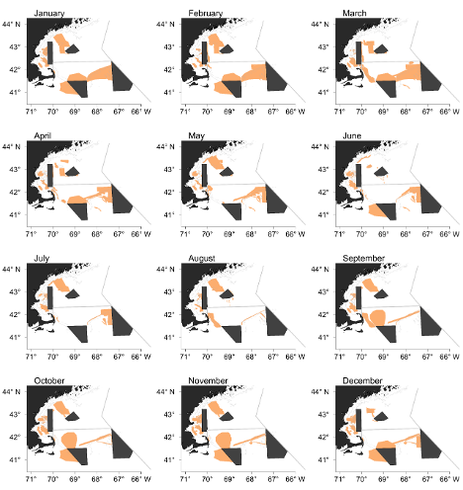

Figure 4. Areas where one or more fisher marked a medium-high abundance of cod for the days-at-sea management period (2004-2009) by month, (*n* = 27).

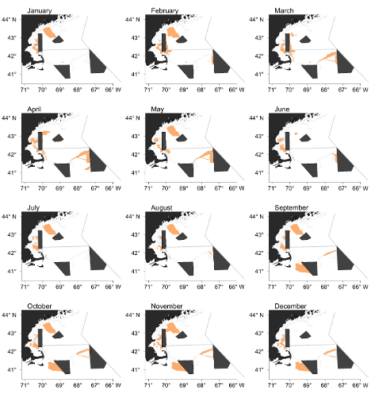

Figure 5. Areas where one or more fisher marked a medium-high abundance of cod for the onset of sectors management period (2010-2012) by month, (*n*=27).

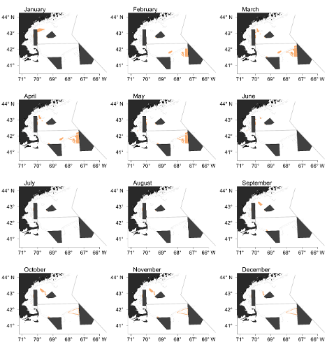

Figure 6. Areas where one or more fisher marked a medium-high abundance of cod for the sectors with cod cutbacks management period (2013-2022) by month, (*n*=24).